SCORM Settings

Articulate

## Articulate Setting Reccomendations

**Key tips (read this first)**

1. Basic configuration for LMS export is just fine, meaning:
2. SCORM 1.2 or + (1.3, 2004) for LMS delivery
3. Set LMS reporting to complete/incomplete
4. For output, select: Zip format for output.
5. IMPORTANT: Make sure that when it zips, the zip archive houses the IMS manifest file at the root level, not hidden under a sub-folder. This should happen by default, but sometimes we see it putting the IMS file under a folder which most LMS don't like

### Exporting from Articulate

1. Go to **Articulate** 🡪 **Options** 🡪 **LMS**.
2. Check **Display SCORM Players** and/or **Display AICC Players**, depending on the standard you would like to use.
3. Click **OK** to save your changes.

Now that you’ve set Articulate Presenter to display LMS output during publish, you’re ready to export out the course, complete with SCORM or AICC metadata tags.

1. Go to **Articulate** 🡪 **Publish** 🡪 **Presentation for Web** and proceed through the Publish Wizard as you would normally do.
2. When you get to the **Select a player template** step of the wizard, select either **Output for SCORM LMS** or **Output for AICC LMS.**
3. Click **Next** and complete the wizard, filling in the metadata for this course to be supplied to your LMS (some of the data, such as presenter name, may be pre-populated based on your Articulate options).

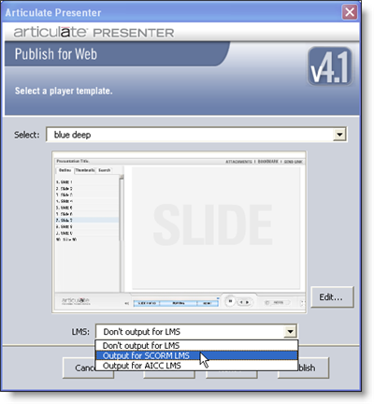

That’s it! Your course is now ready to be uploaded to and tracked by your LMS. Consult your LMS provider for details.